PRESS RELEASE
London, Autumn 2018

LENSFOCUS is the latest fireplace design from Focus, adding heat and harmony to every hearth.

As the saying goes, the eyes are the window to the soul, and the LENSFOCUS certainly gives new meaning to this with its distinctive new design. The fireplace gives the illusion of scanning the interior space with its giant eye whilst fanning the flames from within. With its curved convex glass lens, circular geometric shape and hyper-realistic ceramic logs, the LENSFOCUS creates a spellbinding and hypnotic centrepiece.

This new gas fire, designed by Focus’ founder and creative powerhouse, Dominique Imbert, is a built-in balanced-flue fire using either natural gas (6-7kW) or propane (3,6-4,1kW). LENSFOCUS is the very essence of comfort and is a CE approved certified stove offering a great sense of well-being. The design of the fire does not require the intake of air from the room, allowing it to be installed in low-energy buildings.

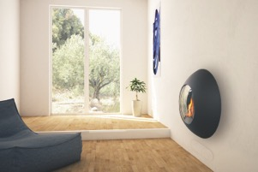
The LENSFOCUS operates without electrical power, and can be used (ignition, programming, regulation, etc.) easily by remote control; a luxury appreciated by users. Thanks to its dual use technology, the fireplace operates independently of the surrounding air, making it ideally suited for low-energy consumption buildings and passive house constructions.

It’s the little things that make the difference…
The LENSFOCUS takes up remarkably little space for such a radical design. Unlike a traditional built-in fireplace, the LENSFOCUS requires minimal depth, so it fits very easily into most rooms without encroaching on wall space.
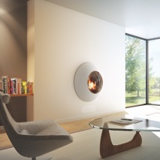
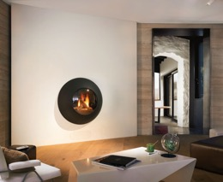
Technical data :
- Gas fireplace that is controlled by a steel cap remote control with a diameter of 84cms
- Colour options: black, white or grey.
- Glazed porthole with a diameter of 46.5 coms
- Performance with a natural gas supply: - Heating capacity: from 6 to 7 kW, Consumption: from 0.644 to 0.723 m3 / hour
- Performance with a propane gas supply: - heating rate: from 3.6 to 4.1 kW , consumption: from 0.116 to 0.144 m3 / hour
About Focus
It was in 1967 that Dominique Imbert created his first groundbreaking design, the Antéfocus fireplace, made for his own personal use, from his sculpture studio located at the foot of the Cevennes in the South of France. However it was in 1968 that Dominique’s Gyrofocus defined the history of Focus. Since then many different Focus fireplaces are found in private homes, hotels as well as in the design museums (New York, Stockholm etc). In addition, Focus has been awarded numerous international awards. 2018 marks the 50th Anniversary of the company.
www.focus-fireplaces.com

Discover the Focus augmented reality app on Google play or the App store

Further press information and images from:
Julienne Webster/Helen Gonzalez at Industry Publicity on 020 8968 8010 or hq@industrypublicity.co.uk

